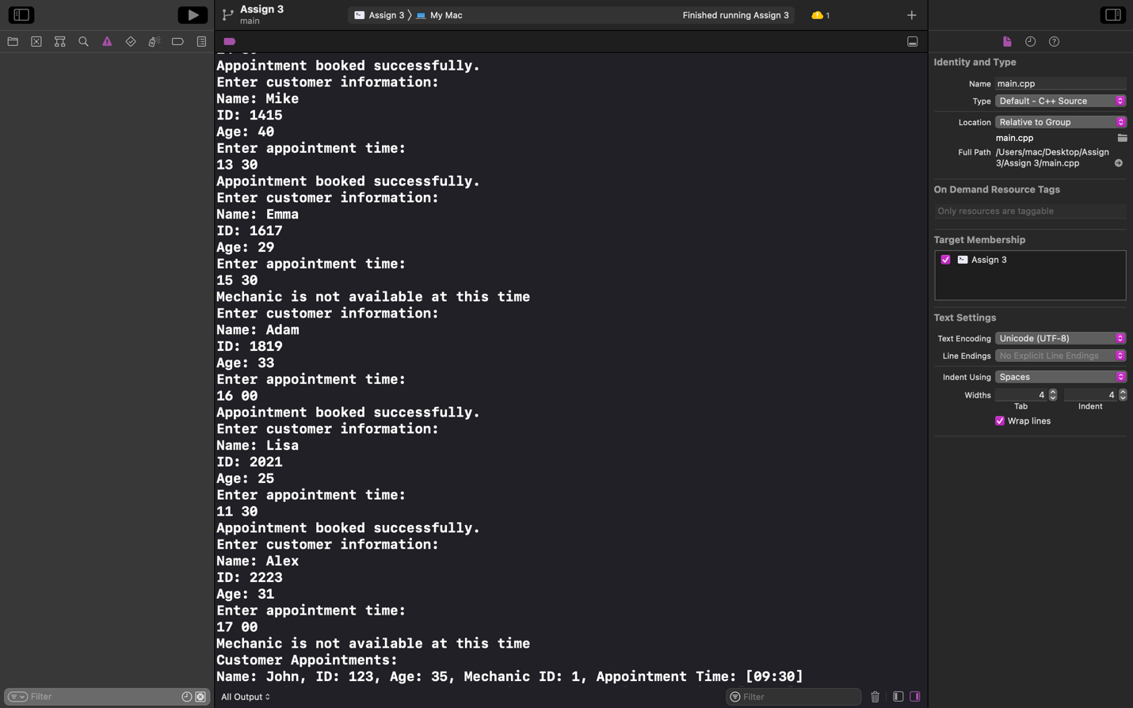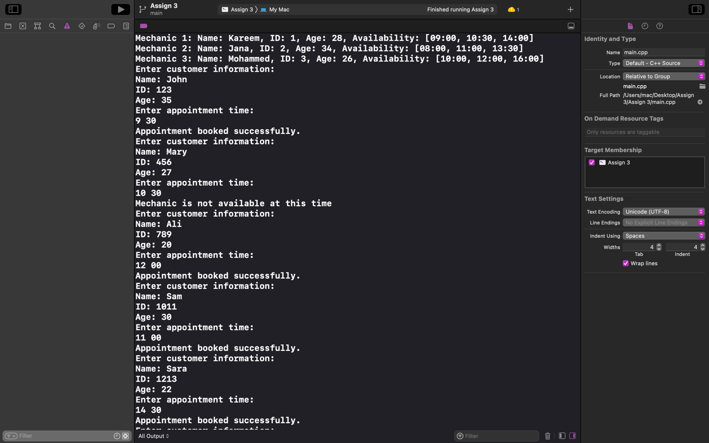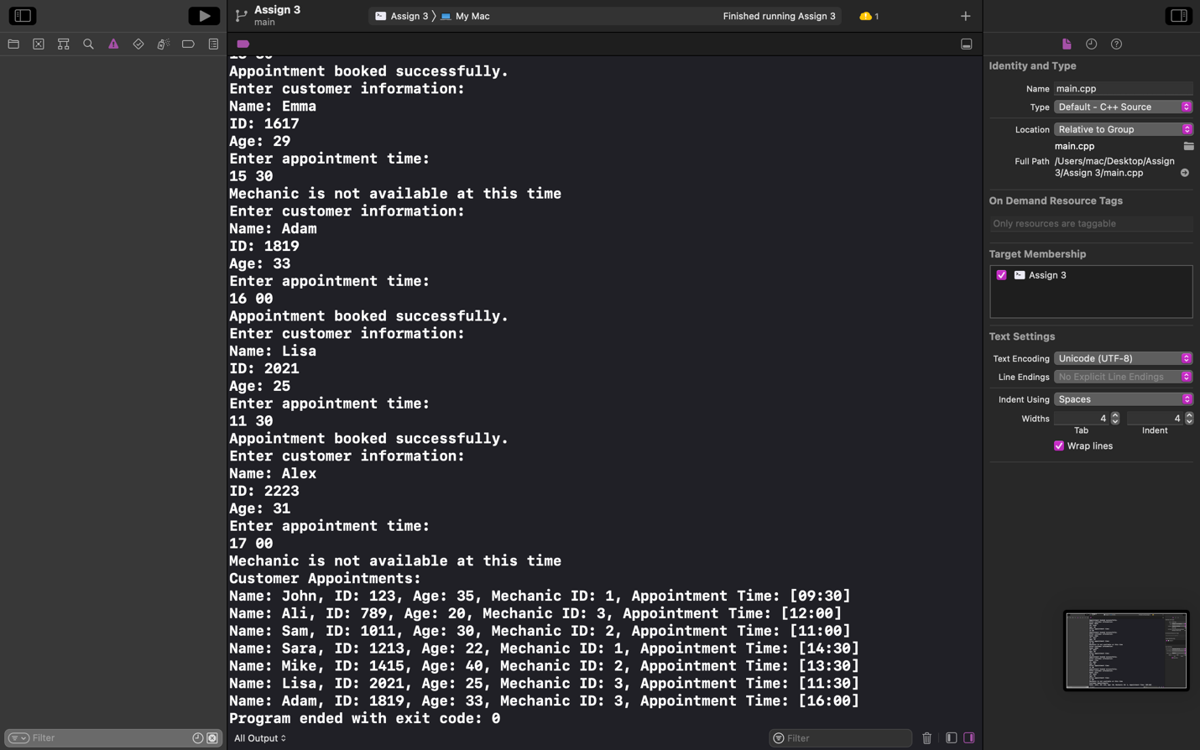

Output: The output displays information on the existing mechanics and all the appointments and their times. It also displays whether the appointment was successfully created since the times could clash with other appointments with the same mechanic. However, the output is very long since it calls the printInfo function multiple times.